WOOLLEN HAT
Double knit or 4 ply wool:
Size 8 (4mm) Needles
2 oz of wool
Cast on 120 stitches.
Rib (2 plain 2 purl ) for 12 inches
Next Row – Knit 2 together to end of the row Purl next row.
Repeat these two rows once more.
Knit 1 row.
Purl 1 row.
Pull thread through all stitches and sew up seam.

MUFFLERS
You will need:
Two needles, size 6
8 ozs of double knitting wool – whatever colour/colours are available.
Stripes are very welcome!
Mufflers encircle throat twice, ends covering chest and should not be more than 10” wide and 5ft long.
Cast on 40 sts.
Work in Plain throughout.

BALACLAVA PATTERN
You need one pair of size 10 (3mm) needles and one pair of size 8 (4 mm) needles, and 100 grams of double knitting wool.
With size 8 needles cast on 150 stitches.
1st Row: K2, (P2, K2) to end of row.
2nd Row: P2, (K2, P2) to end of row.
Repeat 1st and 2nd rows until the work measures 6ins.
Next Row: (K2, P2) 3 times and slip these stitches onto a safety pin, (K2, P2) to last 12 stitches and slip these on to a safety pin.
Continuing in rib decrease 1 stitch at each end of next 4 rows then the following 2 alternate rows (114 stitches). Continue until work measurers 12 ins.
Crown
1st Row: Work 71. S1, K2tog, psso, turn.
2nd Row: Work 29, P3tog, turn.
3rd Row: Work 29, S1, K1, psso, turn.
4th Row: Work 29, P2tog, turn
5th Row: Work 29, S1 K2tog, psso, turn
6th Road: Work 29, P3tog, turn.
Repeat from 3rd to 6th Row 12 times, then 3rd and 4th rows once (30 stitches).
Next Row: Work to end, pick up and P1 along the side edge of next row down.
Next Row: Work to end, pick up and K1 along the side edge of the next row down.
Repeat last 2 rows.
Next Row: Work to end, pick up and K1 along side edge of next row down.
Next Row: Work to end, pick up and P1 along side edge of next row down.
Repeat last 2 rows (38 stitches)
Break off wool and leave stitches on needle.
Slip 12 stitches from first safety pin on to a size 10 needle. Rejoin wool and pick
up and knit 20 stitches along the side edge to stitches on needle, work 38 stitches from needle; pick up and knit 20 stitches along side edge to stitches on second safety pin and work these 12 stitches (102 stitches).
1st Row: P2, (K2, P2) to end.
2nd Row: K2 (P2, K2) to end.
Repeat last two rows twice, then 1st row once. Cast off loosely in rib.Sew front neck seam.

FINGERLESS MITTENS ON TWO NEEDLES
Materials : 3 x 25g balls Double knitting Wool
Pair each Nos 3mm (11) and 3 ¾ mm (9) needles.
Measurements : Width above thumb 8 ½ in (21cm)
Tension : 23sts and 31 rows to 4 in. Measured over stocking stitch on No 3 ¾ mm needles.
RIGHT MITT
With no 3mm needles, cast on 50sts and work 20 rows in K1, P1 rib.Change to no 3 ¾ needles
1st row Knit
2nd row Purl to last st. K1 **
3rd row K26, M1, K1, M1, K23. Work 3 rows
7th row K26, M1, K3, M1, K23. Work 3 rows
11th row K26, M1, K5, M1, K23
Continue increasing in this way on every following 4th row until there are 62 sts.
Work 1 row.
Thumb: Next row K40, turn. Next row K1, P14, turn. Cast on 3 sts (18 sts) Work 4 rows with these 18 sts. Work 2 rows rib as before.
Cast off loosely in rib. With right side facing, rejoin yarn and knit up 3 sts from cast-on sts at base of thumb; k to end (50sts) Work 13 rows.
First Finger: Next row K32, turn. Next row K1, P13, turn. Cast on 2sts (16 sts) Complete as for thumb.
Second Finger: With right side facing, rejoin yarn and knit up 2 sts from cast on sts at base of First Finger, K6, turn. Next row K1, P13, turn, cast-on 2sts (16sts). Complete as for thumb.
Third Finger: With right side facing rejoin yarn and knit up 2 sts from cast-on sts at base of Second Finger, K6, turn. Next row K1, P13, turn. Cast on 2 sts.Complete as for thumb.
Fourth Finger: With right side facing rejoin yarn and knit up 2 sts from cast-on sts at base of Third Finger, K6. Next row K1, P12, K1 (14sts ) Complete as for thumb.

LEFT MITT
Work as for right mitt to **
3rd row K23, M1, K1, M1, K26. Work 3 rows
7th row: K23, M1, K3, M1, K26. Work 3 rows
11th row: K23, M1, K5, M1, K26
Continue increasing in this way on every following 4th row until there are 62 sts. Work 1 row.
Thumb: Next row K37, turn. cast on 3 sts. Next row K1, P16, K1, turn. Complete as for right mitt.
With right side facing, rejoin yarn and knit up 3 sts from cast-on sts at base of Thumb. K to end (50sts) Work 13 rows
First finger: Next row K32, turn. Cast on 2sts. Next row K1, P13, K1, turn.
Complete as for right mitt.
Second finger: With right side facing, rejoin yarn and knit up 2 sts from castonsts at base of First Finger, K6 turn, K1, P13, cast on 2 sts.
Next row: K1, P14, K1, turn. Continue as for right mitt.
Third finger: Work as for right mitt.
Fourth Finger: Work as for right mitt.
To make up: With wrong side of work facing, block by pinning out round edges, and omitting ribbing. Press following instructions on the ball band. Using a flat seam, join thumb, finger and side seams. Press seams.

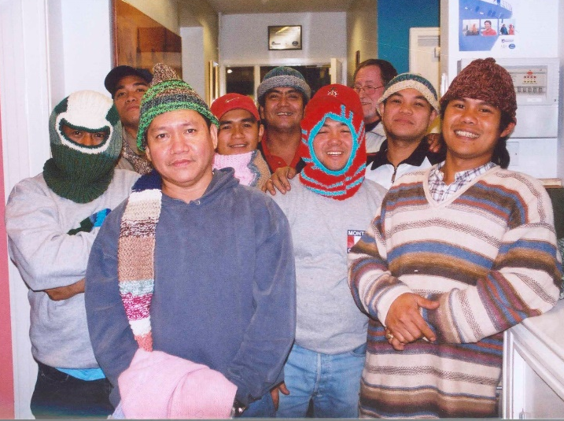

Thank you. Knitting received is very much appreciated and are being sent out to the port centres on a regular basis. Our port chaplains are always taking supplies on board when ship-visiting and the seafarers are so grateful.

If you like a letter of acknowledgement, please provide your full postal address/email address. However, as a charity, we are always looking at ways to save money so if you are happy not to receive a letter of acknowledgement (or if you have an email address where I can send it to), do please let me know.

Tel: +44 (0)20 7248 5202 Website: www.missiontoseafarers.org

Please let us know if you require any freepost labels (and to which address you would like these sent to) in order to post us knitting to:

